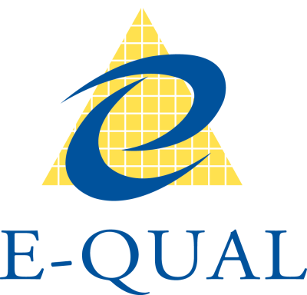

E-Qual Logo

Colourful outstretched hands

Colourful outstretched hands

**Accessible and Inclusive Recruiting**

Volunteering provides benefits for the volunteer, the volunteer organisation and the community. People with disability volunteer too.

**For the volunteer –** skills, experience, opportunity to explore interests, a valued role and new relationships.

**For the organisation -** diverse thinking, experiences and strengths and a team that reflects the community.

**For the community –** a larger pool of volunteers that reflects their membership and supports an inclusive culture.

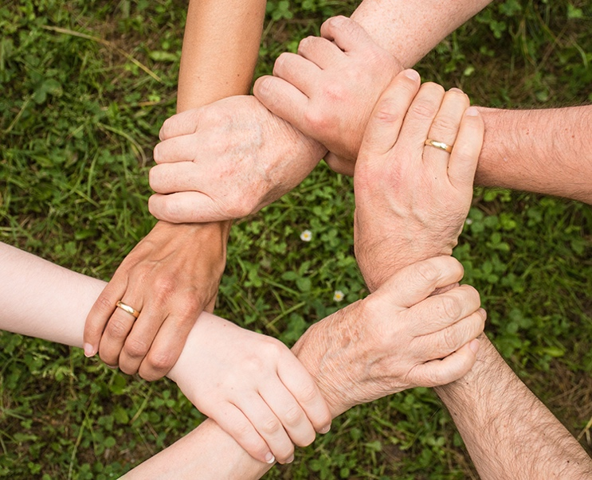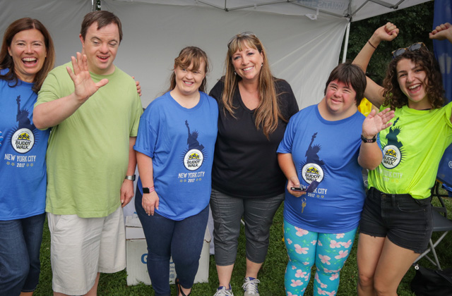

Image: Group of volunteers

Image: Hands linking at the wrist to form a circle

To be inclusive think about the following when you are recruiting:

* Is your information (printed and online) easy to find and read?
* Can people access or request information in a different format e.g. MS Word or large print?
* Can you offer flexible volunteering options e.g. part time, home based, job sharing?
* Are the places volunteers meet for work or training accessible for wheelchair users?
* Can people have a look at the volunteering work and workplaces before they apply?
* Can you make changes to the work environment to address sensory issues for people with autism e.g. reduce noise or strong smells, adjust lighting or temperature?
* Can a volunteer bring their support person or assistance animal when they are volunteering?
* Can you consider adjustments to work methods e.g. change how things are done or create work instructions?
* Have your staff participated in disability awareness training?





Colourful outstretched hands

Image: The word ‘solution’ below speech bubbles

See our **Inclusive Volunteering Fact Sheet - Supporting Volunteers with Disability** for tips on how to support a person to work safely and effectively.

There are also many free resources to support accessible and inclusive recruitment practices including checklists and links.

* [**JobAccess**](https://www.jobaccess.gov.au/) **–** Commonwealth Department providing extensive information about recruiting and supporting people with disability and funding to support work opportunities
* [**Australian Network on Disability**](https://www.and.org.au/) **–** peak body providing information on best practice in recruiting and employing people with disability
* [**Diversity Council of Australia**](https://www.dca.org.au/) **–** peak body providing information on including people from diverse backgrounds and with diverse skills and abilities

***“Do you have an impairment or medical condition that could impact how you do this work? If yes, what support do you need to be able to do your work safely and effectively?”***

If you answer no or don’t know to any of the above don’t worry, help is available.

People with disability are the experts about what they need and how to make adjustments so they can be included, so just ask! You can’t ask about the details of someone’s disability or medical condition but you can ask: